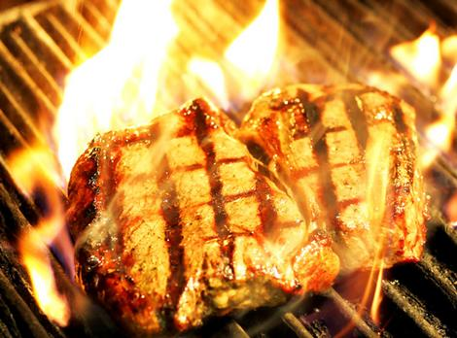**Brazilian BBQ @ Lake Taghkanic**

**(and not the cheap stuff)**



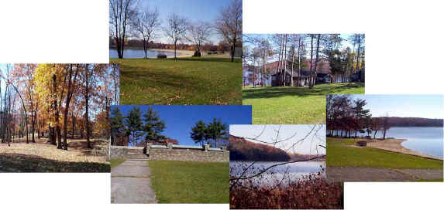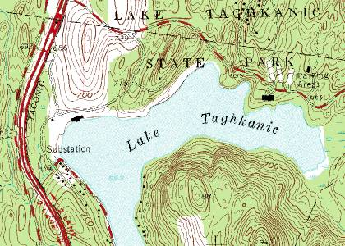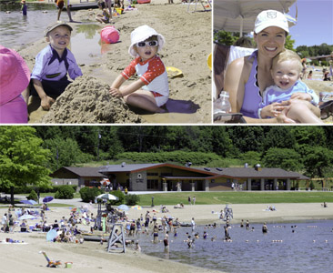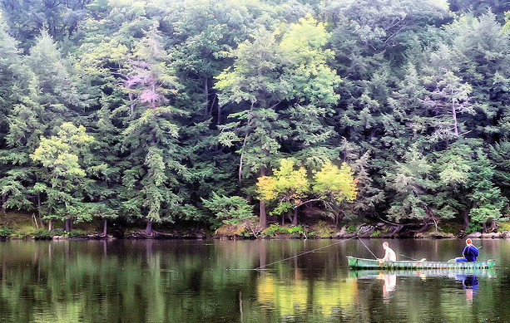

**We are going to Lake Taghkanic. It is a beautiful park with opportunities for us to go on** **boat rides, hiking, fishing, or simply rest and take pictures. Come and mingle with other young adults (ages roughly 18-39) from North Jersey. Our group consists of singles and young couples, some with young children.**

**One of our members (Daniel No) grew up in Argentina and is an excellent cook and lover of meat. We will collect $20 from each person to cover the cost of meat (and we’re not buying cheap stuff, but the gooooood stuff) and entry to the park. After lunch, you are free to partake any activities such as hiking, go on boat rides (and fish), or just hang out and chat with others. Groups will form.**

**This is a great opportunity to meet people in the area. So join us!**

**Note: if you bring your car and are willing to carry at least three additional people in your car, the $20 will be waived.**

**Our meeting location is at:**

**1155 Hendricks Causeway**

**Ridgefield, NJ 07657**

**9am, August 25, 2012 (Saturday)**

**We'll greet, load anything we need, and carpool as needed from there.**

**Sign up at the church or at meetup.com  
(links @ http://www.to1another.com)**